Table of Contents

**Maha Shivaratri: The Great Night of Lord Shiva** 2

Introduction: A Night of Divine Union and Devotion 2

Historical Background of Maha Shivaratri 2

Mythological Significance 3

1. The Divine Marriage of Shiva and Parvati 3

2. The Night Shiva Performed the Cosmic Dance 3

3. Churning of the Ocean (Samudra Manthan) 3

Religious Customs and Observances 3

Celebration Across Indian 4

Conclusion: A Night of Awakening and Surrender 4

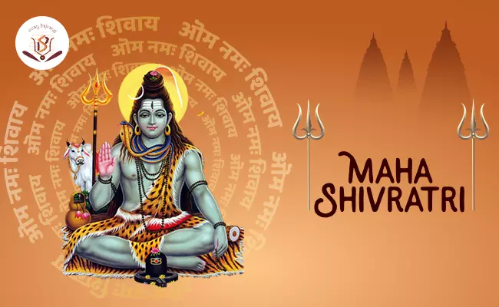

# **Maha Shivaratri: The Great Night of Lord Shiva**

## Introduction: A Night of Divine Union and Devotion

**Maha Shivaratri**, meaning “The Great Night of Shiva,” is a major Hindu festival celebrated annually in honor of **Lord Shiva**, one of the principal deities of the Hindu trinity (Trimurti). Falling on the **14th night of the dark fortnight in the month of Phalguna** (February–March), this sacred occasion is marked by **fasting, night-long vigils, and spiritual practices**. Maha Shivaratri is a time for inner reflection, destruction of ego, and union with the divine consciousness represented by Shiva.

## Historical Background of Maha Shivaratri

The origins of Maha Shivaratri can be traced back to **ancient Vedic texts** and **Puranic stories**. While it is not primarily a harvest festival or seasonal observance, it holds immense **spiritual and cosmic importance** in Hinduism. It symbolizes the **overcoming of darkness and ignorance** in life and the world.

Unlike many other festivals, Maha Shivaratri is primarily **a night of worship** rather than celebration. Historically, it has been observed by ascetics, householders, and devotees across India, Nepal, and other parts of the Hindu world for thousands of years.

## Mythological Significance

Maha Shivaratri is surrounded by several important legends, each adding depth to its spiritual meaning:

### 1**. The Divine Marriage of Shiva and Parvati**

One popular belief is that Maha Shivaratri commemorates the **wedding of Lord Shiva and Goddess Parvati**. Devotees celebrate the divine union of consciousness (Shiva) and energy (Shakti), which represents balance in the universe.

### 2. The Night Shiva Performed the Cosmic Dance

Another legend suggests that it was on this night that **Lord Shiva performed the Tandava**, the **celestial dance of creation, preservation, and destruction**. The dance symbolizes the rhythm and cycle of the cosmos.

### 3. Churning of the Ocean (Samudra Manthan)

During the mythological churning of the ocean, a deadly poison called **Halahala** emerged. To save the world, Shiva **drank the poison**, which stayed in his throat and turned it blue, earning him the name **Neelkanth (Blue-Throated One)**. Maha Shivaratri honors his **sacrifice for the welfare of all living beings**.

## Religious Customs and Observances

Devotees observe Maha Shivaratri with **intense spiritual discipline**:

* **Fasting**: Many observe a strict fast, consuming only water, fruits, or milk.
* **Night-long Vigil (Jagran)**: Temples remain open all night as devotees chant "Om Namah Shivaya" and sing devotional songs.
* **Shiva Linga Abhishekam**: Offerings like **milk, honey, water, bael leaves, and sandalwood paste** are poured over the Shiva Linga, symbolizing purification of the soul.
* **Meditation and Mantras**: It is considered a powerful night for meditation, self-reflection, and seeking blessings for spiritual progress.

## Celebration Across Indian

Maha Shivaratri is celebrated differently in various regions:

* In **Ujjain**, where one of the twelve Jyotirlingas (Mahakaleshwar) is located, massive processions and rituals are held.
* In **Kashmir**, it is known as **Herath**, and celebrated with special rituals by Kashmiri Pandits.
* In **Tamil Nadu**, especially at the **Chidambaram and Thiruvannamalai temples**, it’s celebrated with deep devotion and traditional dance festivals.

## Conclusion: A Night of Awakening and Surrender

Maha Shivaratri is not just a festival; it is a **spiritual journey inward**. It teaches the values of **self-control, devotion, and detachment**. Through fasting, prayer, and night-long vigil, devotees aim to overcome ignorance and awaken the divine light within. The night represents the victory of consciousness over darkness, and the Shiva within every being.

Whether seen as a cosmic event, a divine marriage, or a personal night of reflection, Maha Shivaratri continues to inspire **millions to seek purity, peace, and higher truth** in their lives.